**Database Project**

**Catering For Kings Database**

**Objective Of Database Project →** For my database assignment I picked the Catering For Kings case study. From my chosen case study I will design an ERD to hold persistent data. I will also submit the created SQL statements in a single script that will run independently of my schema. Prior to creating the tables, my script will drop the current version of those tables.

**Tables Created →**

*\*****Please note****\*: I forgot to add two variables “****advance fee****” and “****paid fee****” into the Logical and Relational Diagram.* I added them into its appropriate SQL tables and it does not affect the integrity of the data.

Types used: **NUMERIC**, **VARCHAR**, **CHAR**, **VARCHAR2**

Constraints used: **NOT NULL**, **PRIMARY KEY**, **FOREIGN KEY**, **INDEX** and **UNIQUE**

1. **Full Service**

full_Service_ID (**PK**), fmain_Course, f_Starters, f_Desserts

1. **Minimum Service**

minimum_Service_ID (**PK**), m_Starters, mmain_Course, m_Coffee

1. **Party Service**

party_Service_ID (**PK**), pmain_Course, p_Starters, pcheese_Platters, p_Desserts, p_Beverages

1. **Client**

client_ID (**PK**), client_Name, client_Address, client_Number, recieved_Invoice, advance_Fee, paid_Fee

1. **Resources**

resource_ID (**PK**), r_Cutlery, r_Staff, r_Vans, r_Tableware, r_Table, r_Chairs

**Thought Process →**

I decided to create these specific tables from my case study because I felt that these pieces of data were crucial. CFK offers **three** main types of services which are: **Full**, **Minimum** and **Party**. Each service has different offers available to the customer for example the **Party** service which will cater for up to twenty people has a choice of up to four main courses, starters, cheese platters, desserts, wines and other drinks. The **Minimum** service offers a single choice, with a starter, main course and coffee for two**.** This is why I felt it was suitable to create tables for the types of services

I created a **Client** and **Resources** table. The client table was necessary because the client decides what service they want. The client also decides if they want other resources as well such as chairs, tables, tableware. Carol and Annette will also have to hire a staff if the customer wants somebody to serve them the meal.

**Relationships →**

1. client_ID **1:N** full_Service_ID
   * Client can reference any number of rows in the Full Service but each row in Full Service can only be referenced one row in Client (or none)
2. client_ID **1:N** minimum_Service_ID
   * Client can reference any number of rows in the Minimum Service but each row in Minimum Service can only be referenced one row in Client (or none)
3. client_ID **1:N** party_Service_ID
   * Client can reference any number of rows in the Party Service but each row in Party Service can only be referenced one row in Client (or none)
4. client_ID **1:1** resource_ID
   * Client record is only associated with resource
5. party_ID **N:M** resource_ID
   * Each row in Party can reference many rows in Resource this is the same vice versa
6. pmain_Course **1:N** fmain_Course
   * Party Main Course can reference any number of rows in the Full Main Course but each row in Full Main Course can only be referenced one row in Client (or none)

**Thought Process For Relationships →**

1. client_ID **1:N** full_Service_ID → The client gets the option of choosing what type of service they want. That includes main, starters and dessert so I felt the 1:N relationship made sense.
2. client_ID **1:N** minimum_Service_ID → The customer gets the option of choosing what type of service they want. That includes a single choice of main, starters and coffee for two.
3. client_ID **1:N** party_Service_ID → The client gets the option of choosing what type of service they would like. This includes main, starters and dessert, drinks and other beverages.
4. client_ID **1:1** resource_ID → The client gets to decide whether they need extra resource like chairs, tables and tableware
5. party_ID **M:N** resource_ID → The party service would most likely require resources so I felt that it was appropriate to create a
6. pmain_Course **1:N** fmain_Course → They both share the same selection of food in their menu

**Logical Model →**

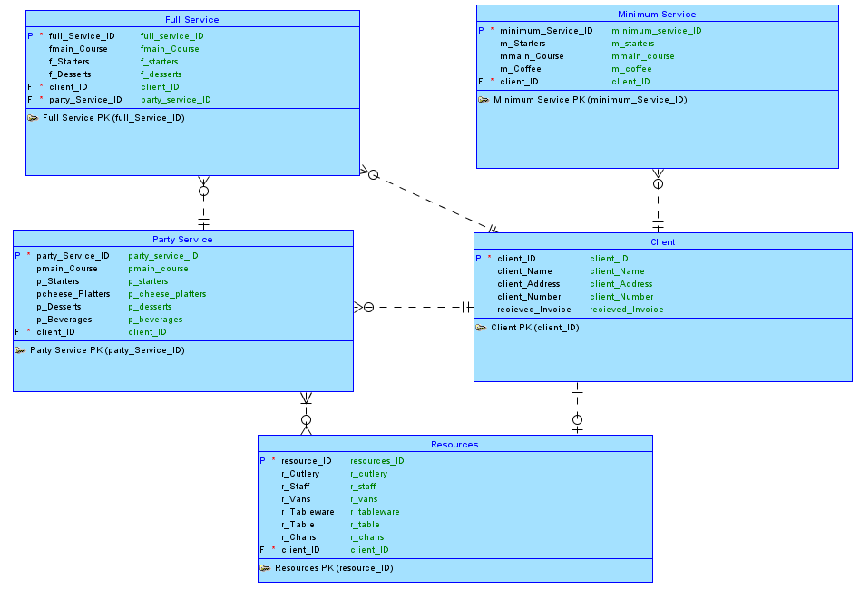

**Relational Model →**

